Interactivity With JavaScript

# 3rd Course in the Web Design for Everyone Specialization

# About Course

If you want to take your website to the next level, the ability to incorporate interactivity is a must. But adding some of these types of capabilities requires a stronger programming language than HTML5 or CSS3, and JavaScript can provide just what you need. With just a basic understanding of the language, you can create a page that will react to common events such as page loads, mouse clicks & movements, and even keyboard input.

This course will introduce you to the basics of the JavaScript language. We will cover concepts such as variables, looping, functions, and even a little bit about debugging tools. You will understand how the Document Object Model (DOM) is used by JavaScript to identify and modify specific parts of your page. After the course, learners will be able to react to DOM Events and dynamically alter the contents and style of their page. The class will culminate in a final project - the creation of an interactive HTML5 form that accepts and verifies input. This is the third course in the Web Design For Everybody specialization. A basic understanding of HTML and CSS is expected when you enroll in this class. Additional courses focus on enhancing the styling with responsive design and completing a capstone project.

# Skills You Will Gain

**Web Development**

**JavaScript**

Document Object Model (DOM)

# Course Materials

General Links

*Additional Reading*

*Beyond Scope*

# Week

Week 1

Notes

# The Document Object Model (DOM)

One of the reasons you want to learn about JavaScript is that it works so well with the structure used to create HTML documents. Every webpage can be broken down into a mathematical tree structure called the Document Object Model (DOM). Each HTML tag is a node in the tree and these nodes have all types of different attributes, such as text, background color, width, etc.

With JavaScript it is easy to write code that basically says "I want to grab that part of the webpage and change it." In this lecture I review the DOM and talk about how it is related to JavaScript. There is no code associated with this lecture, but if you check under the resources I do include a link to site where you can find specifics on the DOM.

Web Pages are built upon the DOM. Points to remember about the DOM:

* Structures documents like a tree
* Every node has one parent, and possibly many children (1:∞)
* Nodes have properties, methods, and events

### **How the API interacts with the DOM**

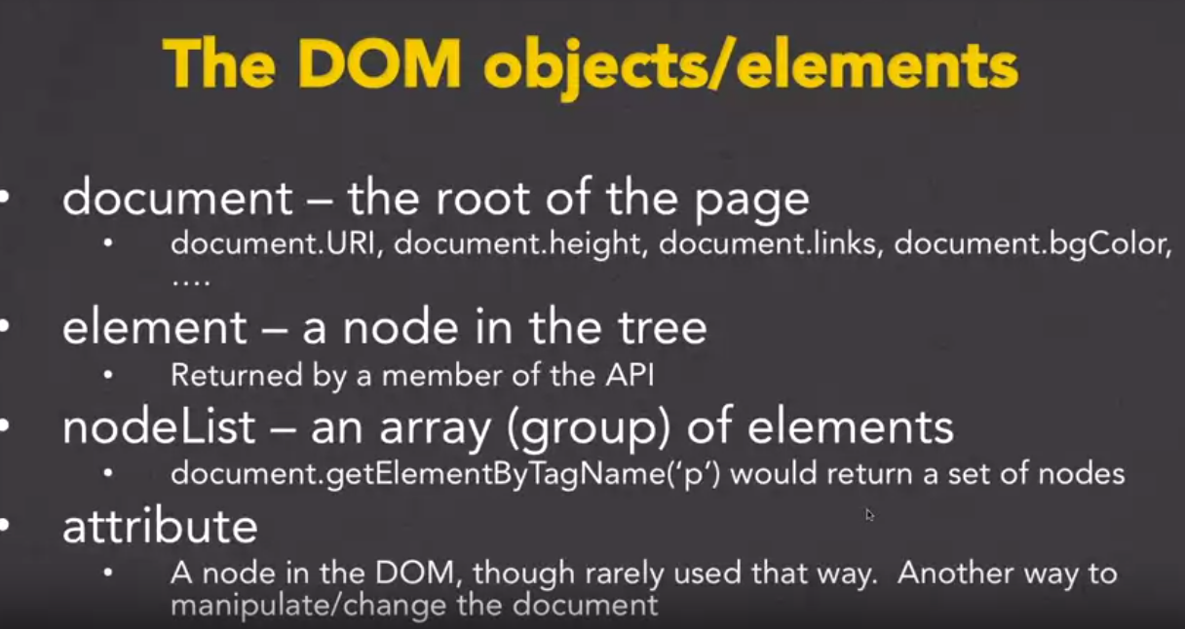

### **Specific APIs examples**

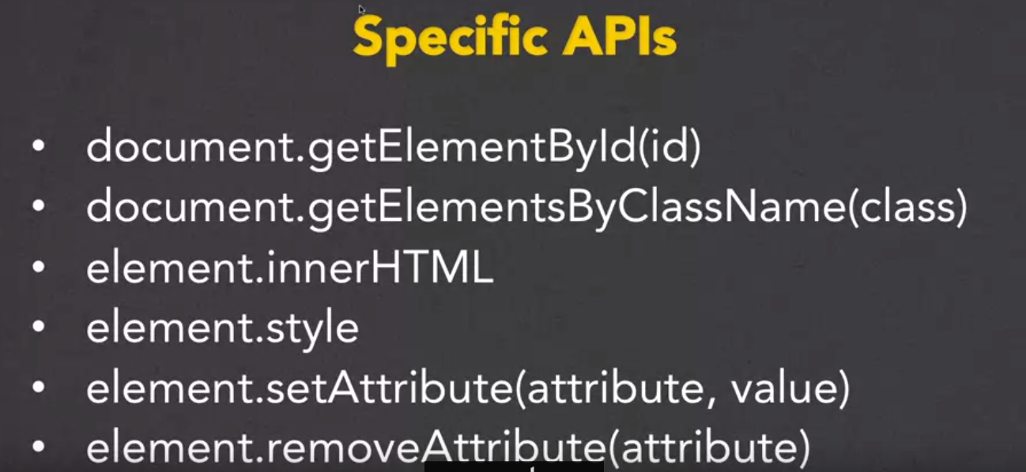

### **JavaScript Capabilities**

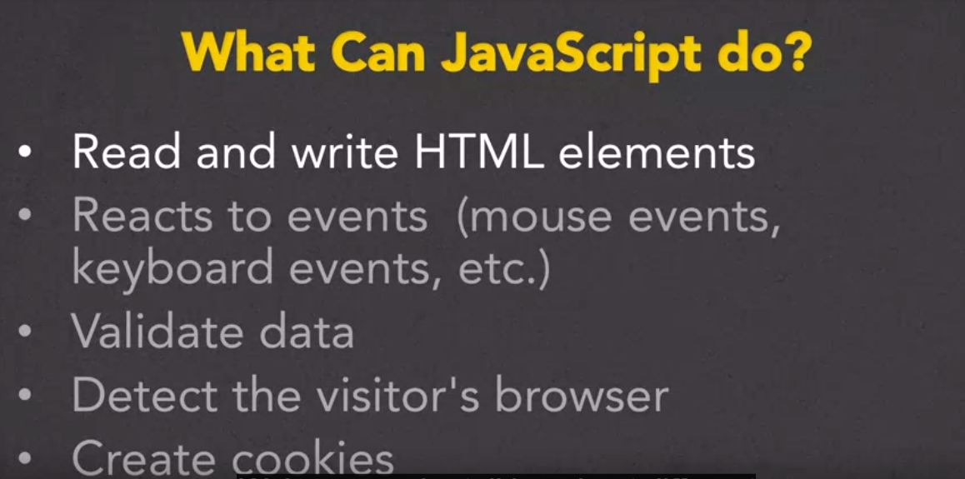

### **JavaScript Outputs**

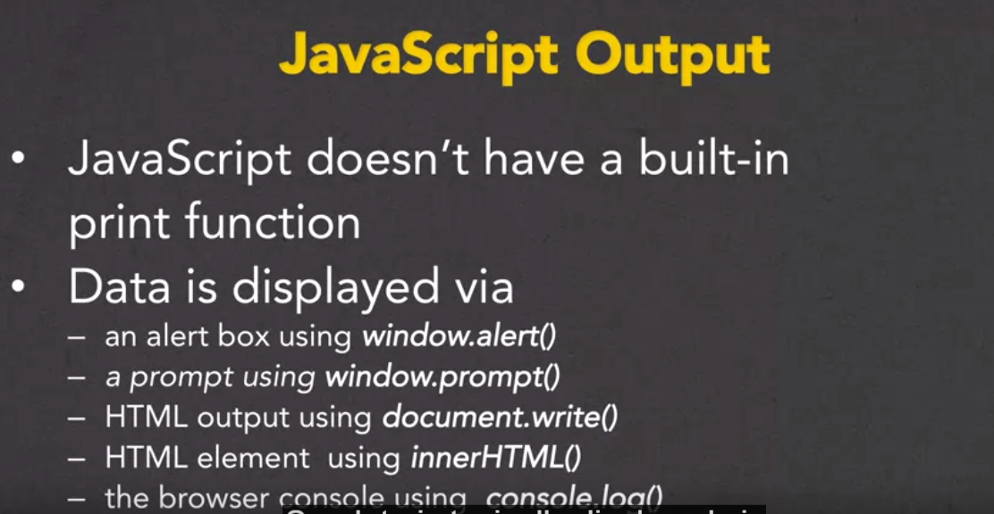

### **Alert with JavaScript**

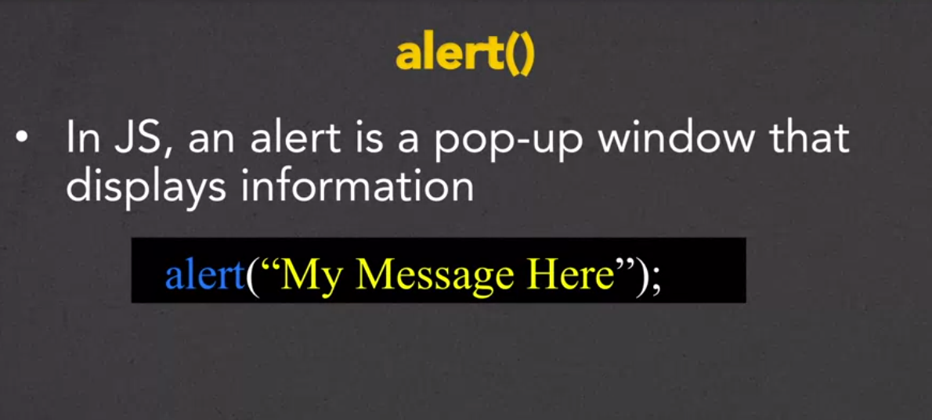

### **Prompt with JavaScript**

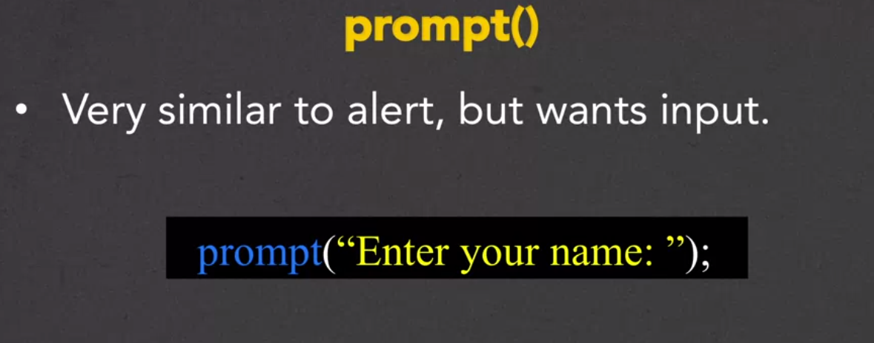

### **Document Write with JavaScript**

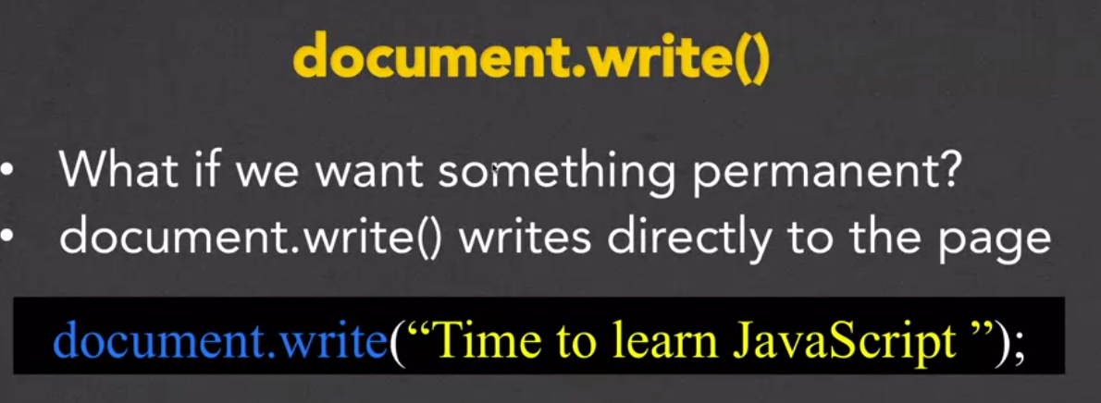

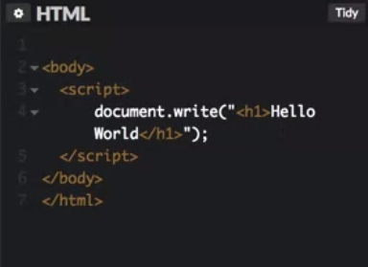

### **InnerHTML with JavaScript**

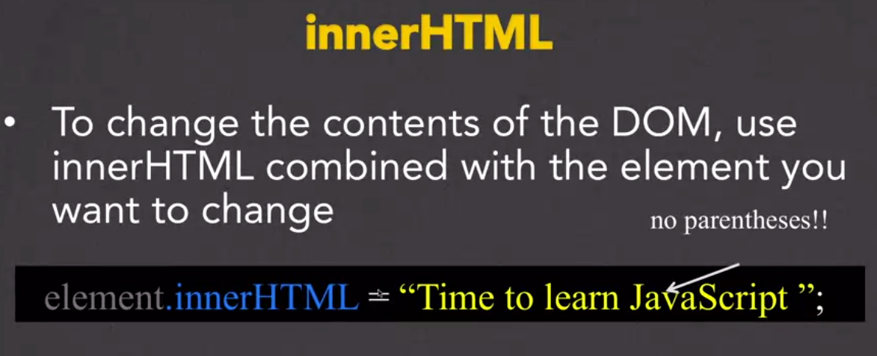

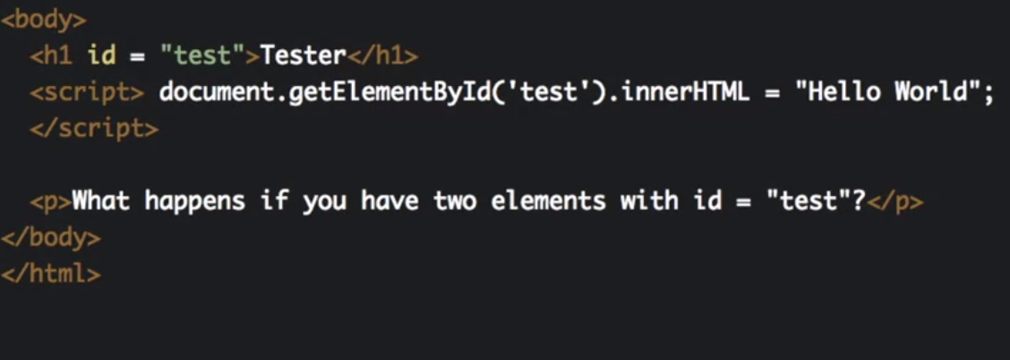

This example will replace the H1 element content or ‘innerHTML’ with the String “Hello World”

Console Log with JavaScript

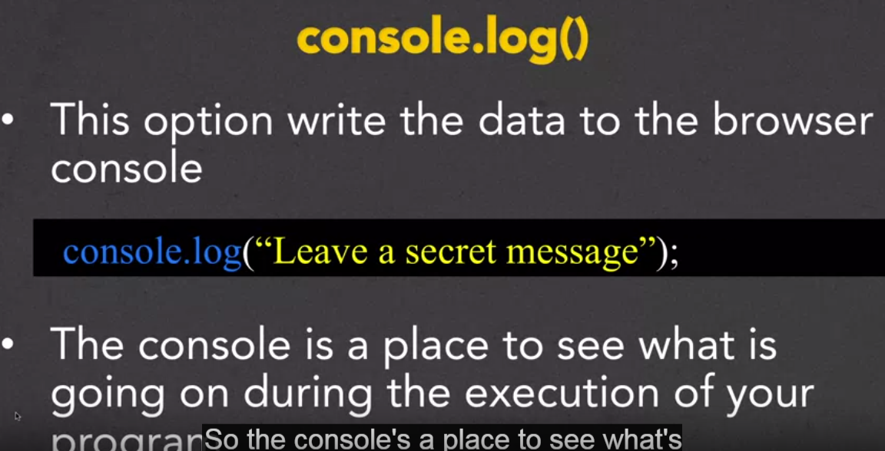

The console has vital features to aid with the development of web pages, for instance, debugging or logging user inputs

#### ***Locating the Console***

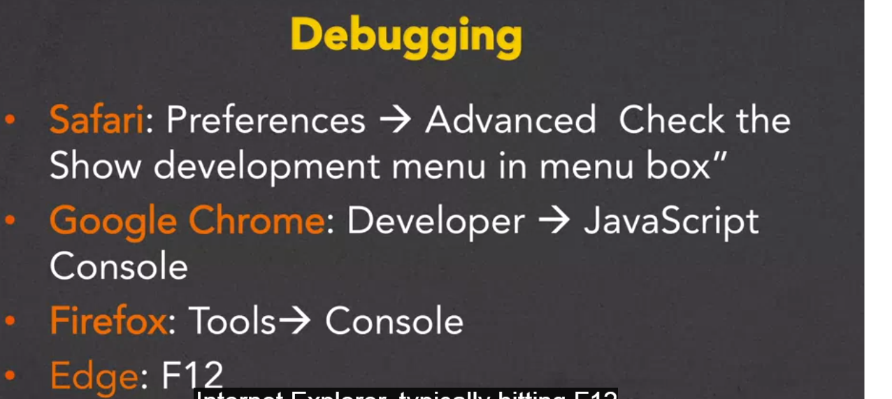

## **Variables**

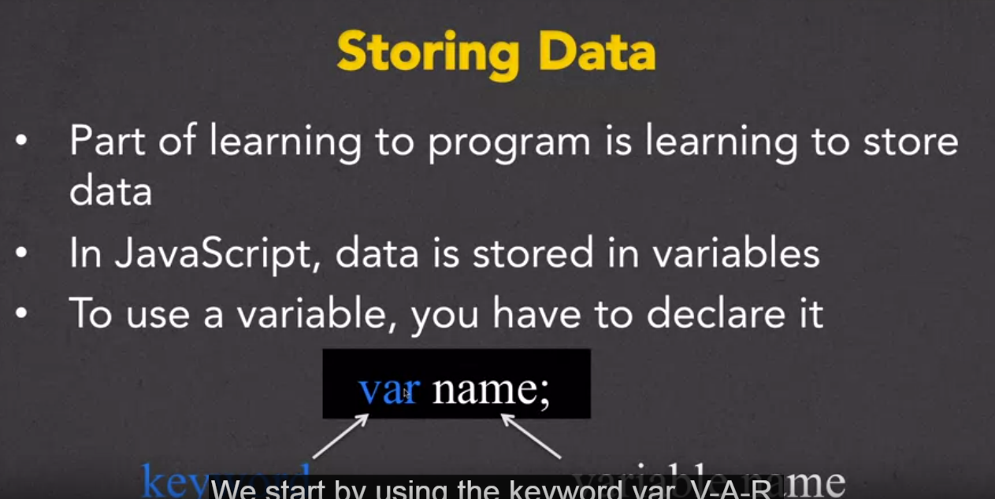

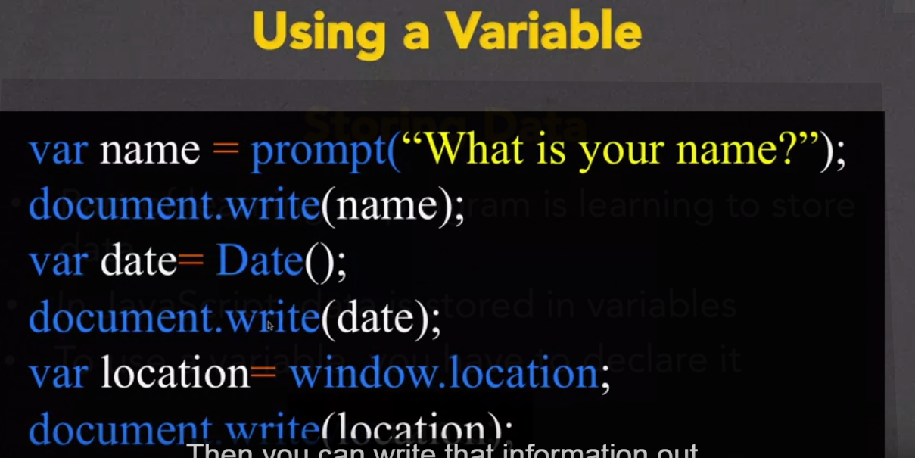

More examples:

var name = prompt("What is you name?");

document.write(name +"<br/>");

var date = Date();

document.write(date +"<br/>");

document.write(location +"<br/>");

document.write("<h2>" +"Hello User!" + "<h2>" +"<br/>");

document.write(document.baseURI+"<br/>");

### **Data Types**

Numbers (includes whole numbers and decimals)

Strings

Objects

Arrays

This example returns an array of attributes that are applied to anchor tag

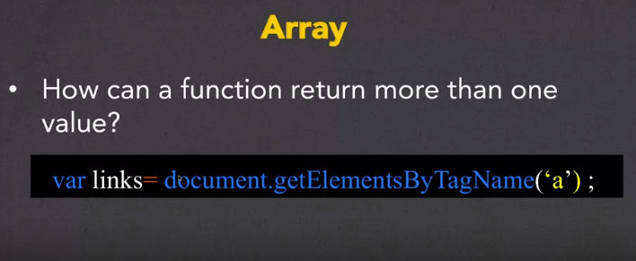

### **Operators and Expressions**

The triple equal operator === checks for equality with value and type

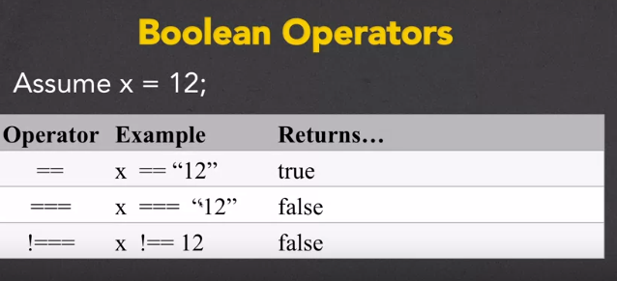

Links

<https://codepen.io/collection/nLPkgP/> (This week CodePen repository)

Closing Thoughts

Week 2

Notes

## **Functions**

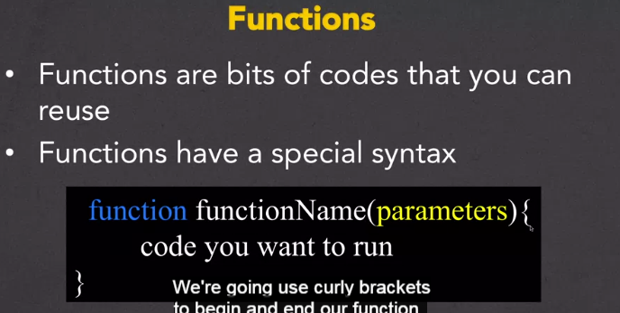

### **Return Values**

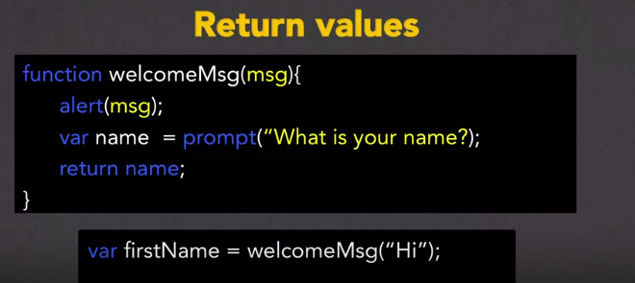

#### ***Linking from an HTML file***

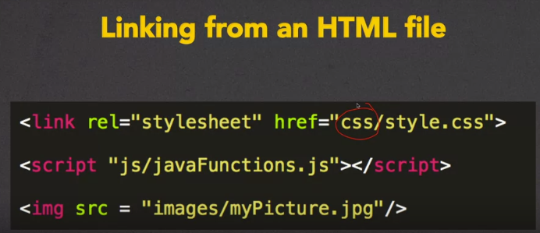

### **Debugging Tips**

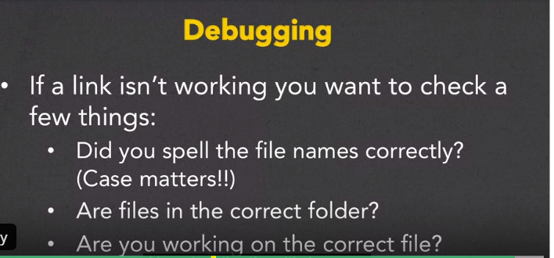

## **Events**

Events or dynamic “function calls” achieved through the JavaScript API

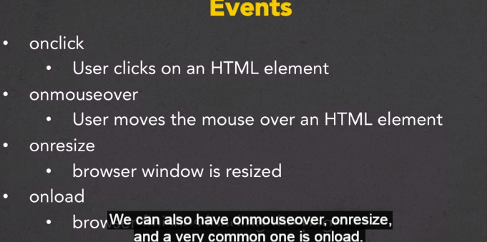

Figure shows a simple example

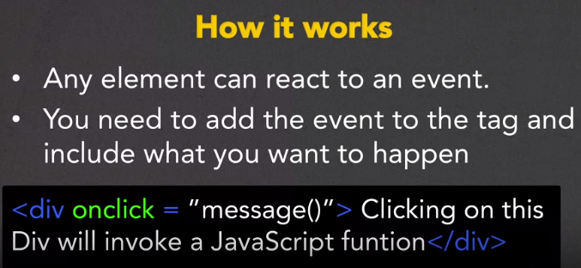

#### ***Using Quotes with Events***

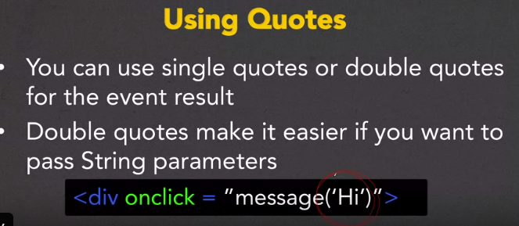

Use double-quotes with nested single-quotes

#### ***More events***

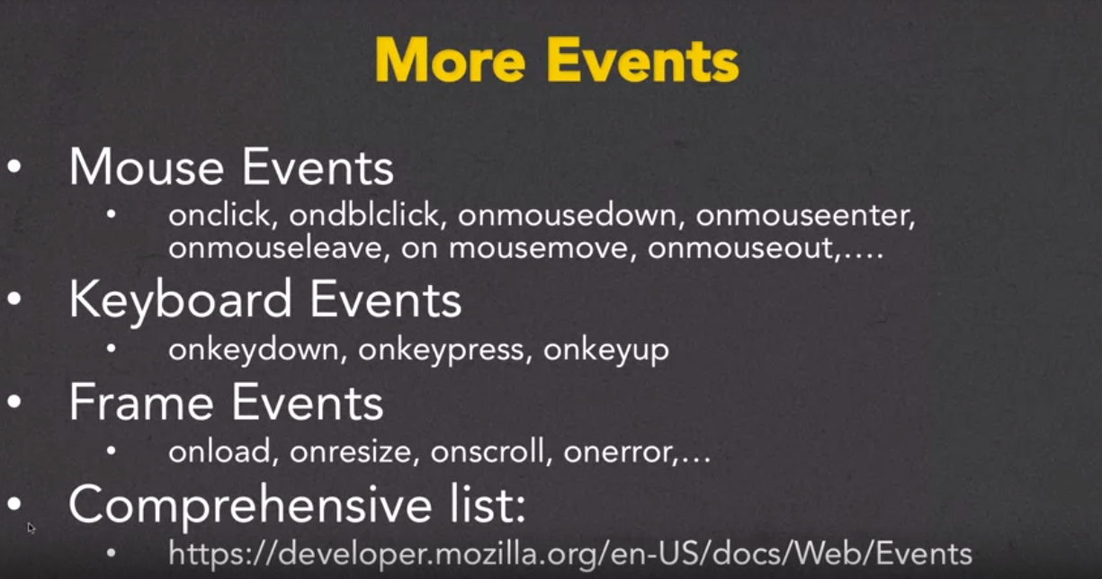

Links

<http://codepen.io/collection/Adbwgo/> This weeks CodePen

<https://developer.mozilla.org/en-US/docs/Web/Events> Comprehensive list of events

Closing Thoughts

Week 3

Notes

Links

Closing Thoughts

Week 4

Notes

# Simple Forms

Basic form creation

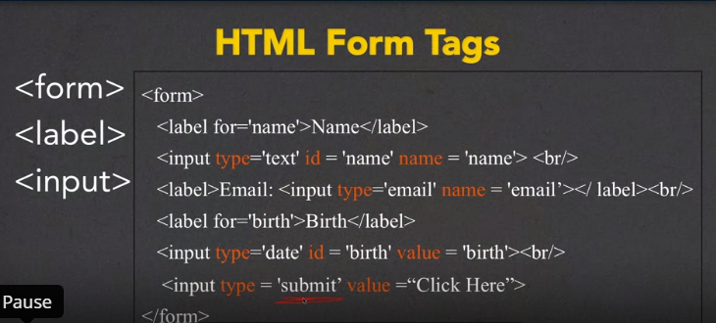  
Remember that not all browsers support all tags this includes form specific tags

### **Input Types**

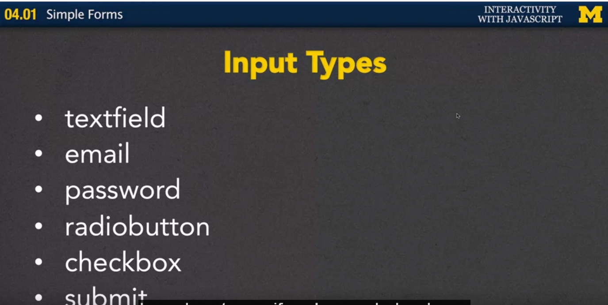

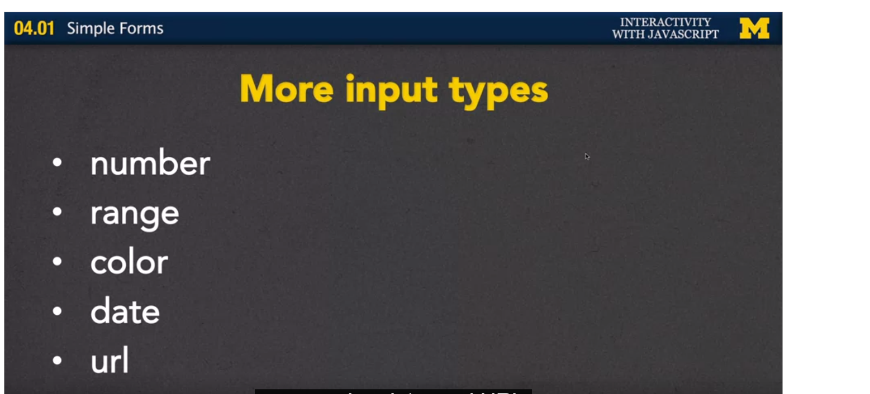

### **A brief look at Attributes**

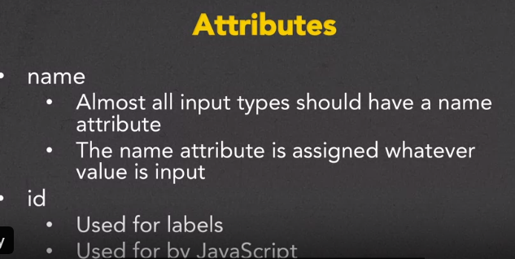

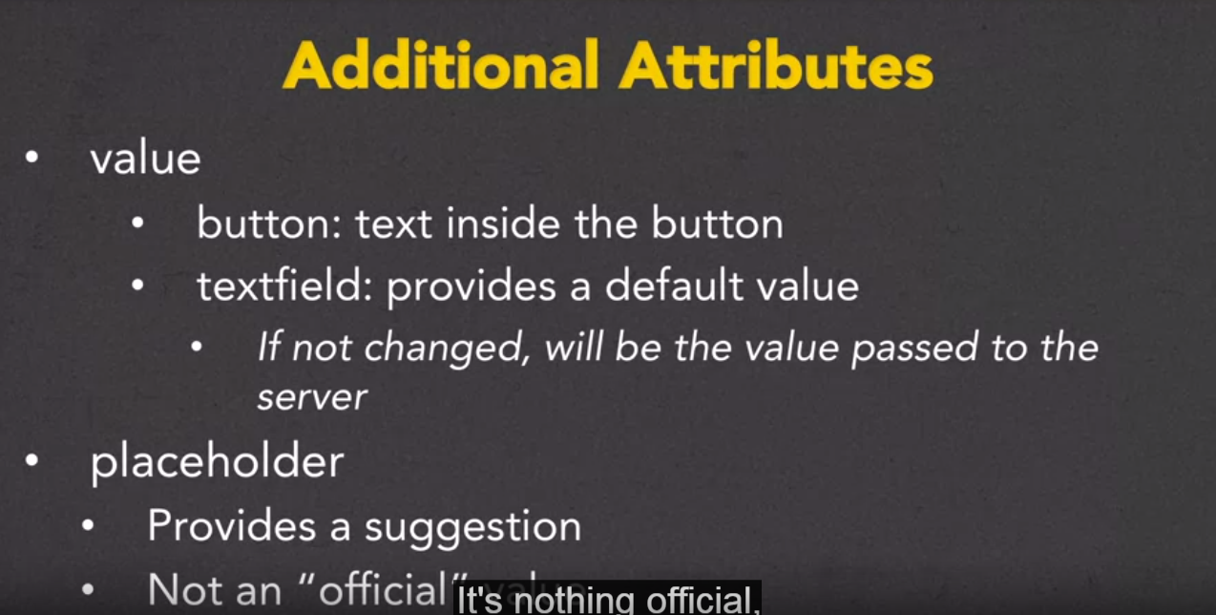

## **Simple Validation**

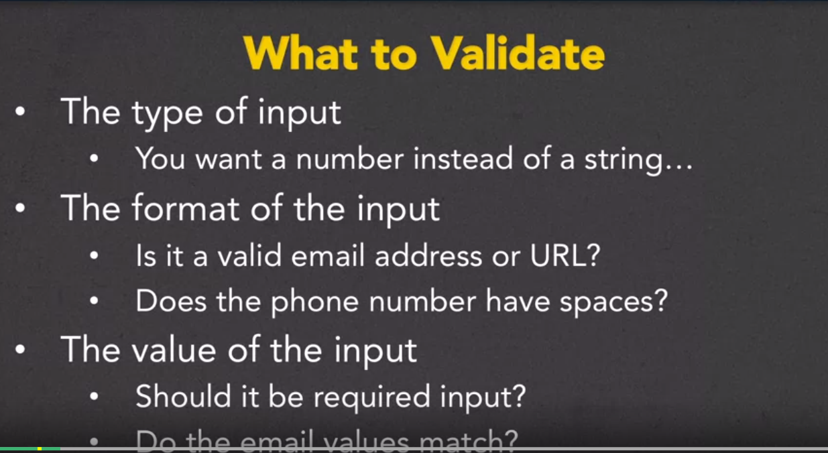

#### ***How to Validate***

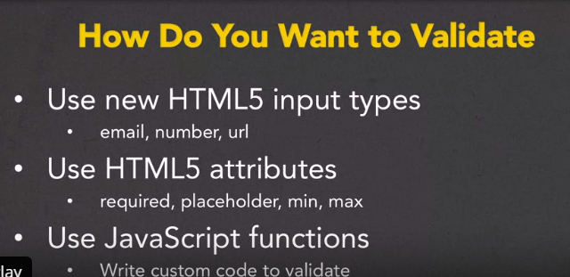

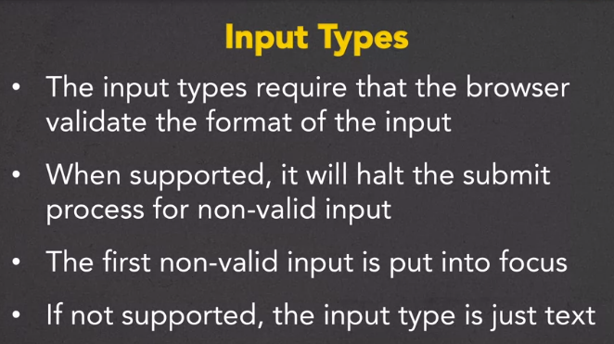

Note when using browser supported tags to validate form input: if the tag is not supported it defaults to accepting plain text which would not validate, say, an email in proper format

#### ***Input Attributes***

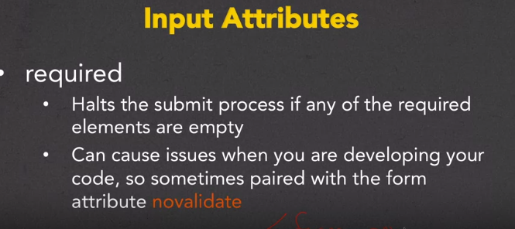

#### ***Using Patterns ( Reg. ex ) for Validation***

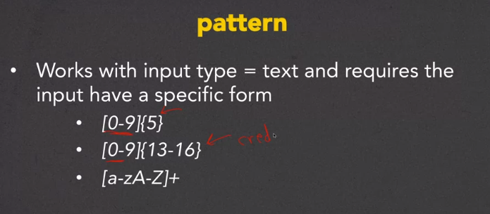

#### ***Limiting Number of Character Inputs***

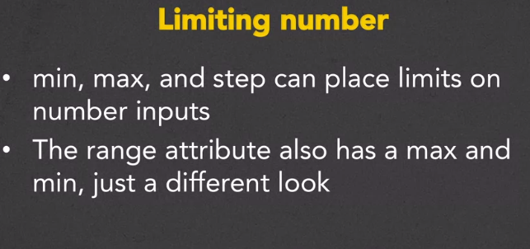

Figure demonstrates validating a zip code for form input

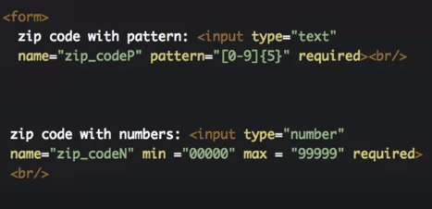

Note that the min attribute here [ min = “00000” ], will not insure that the user inputs a minimum of 5 digits.

## **Comparing Two Inputs**

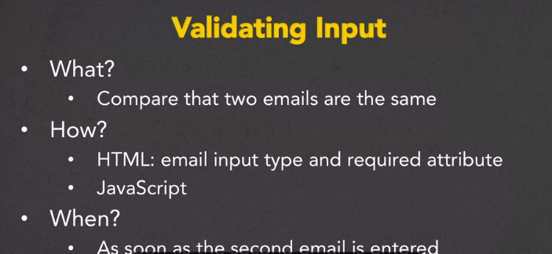

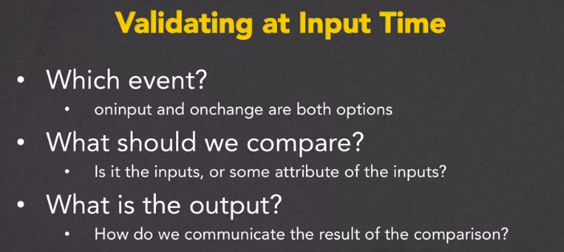

Figures show an example of comparing two inputs

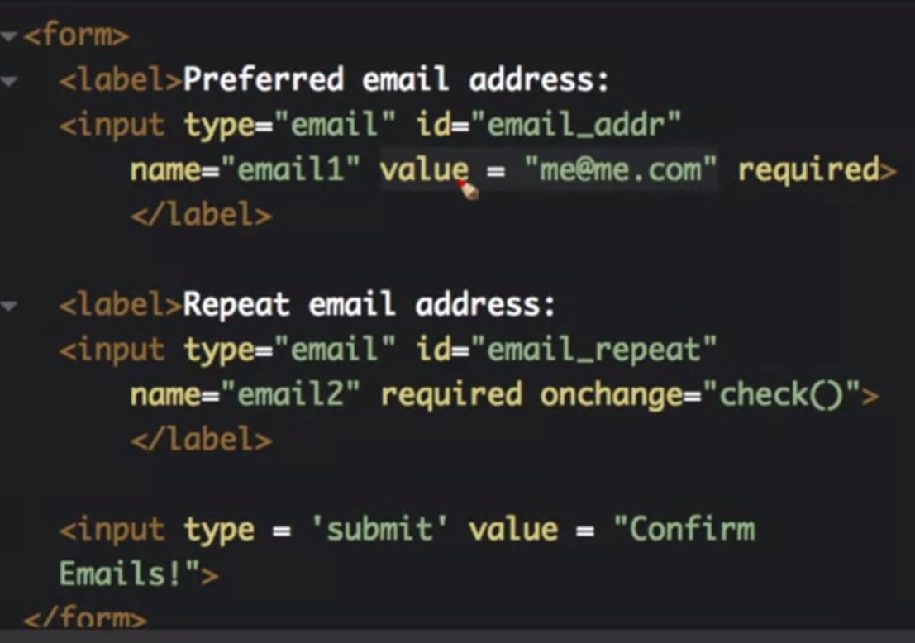 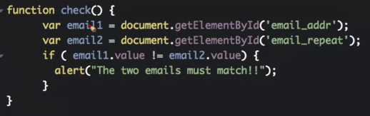

This example would not prevent the user form submitting the form once the alert is dissimissed even if the emails do not match. To enforce this condition use return types

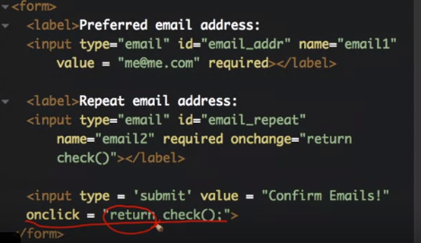 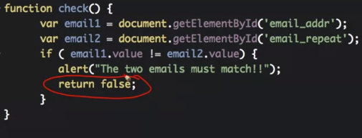

## **Checkboxes and Radio Buttons**

Checkboxes and Radio input types are unique in that they share the same value for the name attribute.

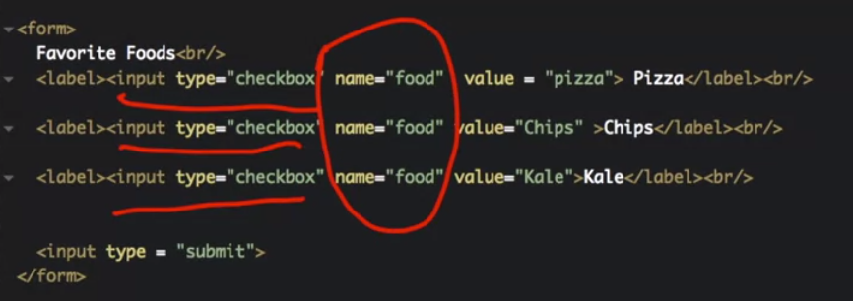

Keep in mind that adding labels to form inputs allow for better accessibility by making both the checkbox and label clickable to select a given option.

Radio buttons allow one option selected pre grouping.

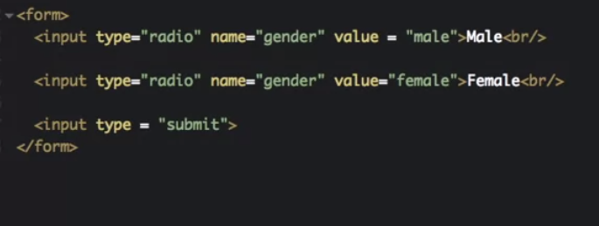

Note in the example above the label tag is excluded meaning you must click the radio button. Clicking the text next to the button will not select the adjacent option.

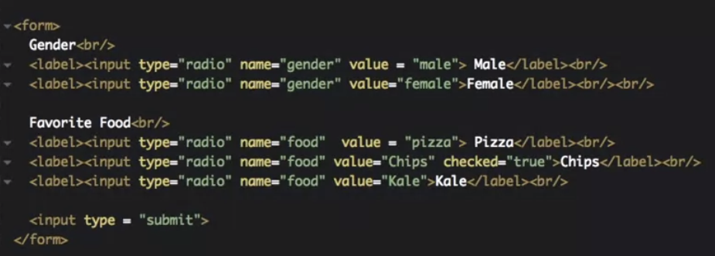

#### ***Validating with Checkboxes and Radio Buttons***

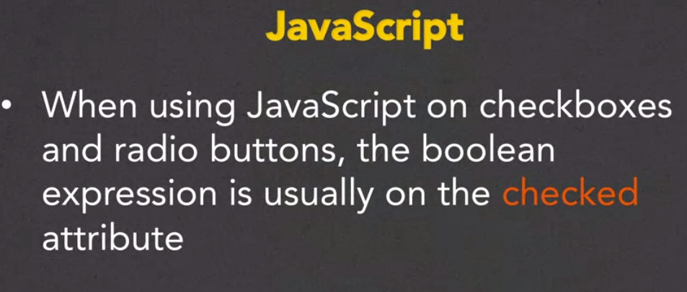

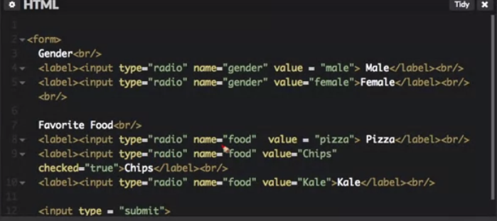

This attribute/value will preselect the radio button when the page loads

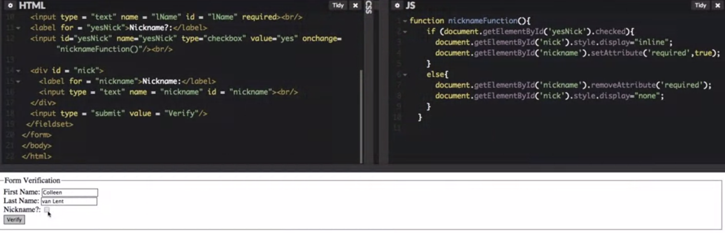

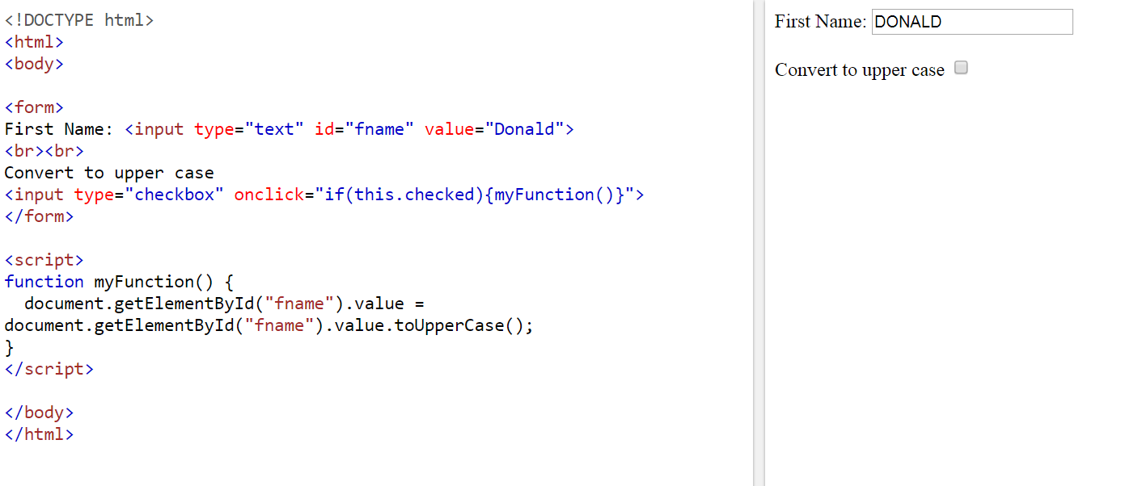

Links

<http://www.html5pattern.com/> reg ex. Patterns

<http://www.wufoo.com/>. For deploying forms

Closing Thoughts

Using Forms on Your Site

As I mentioned earlier, the forms we are making right now are a great way to work with JavaScript, but you wouldn't want to put these forms on your page since you don't know how to deal with the information that people may send. Luckily, now that you know a little about forms you are in a great place to utilize free form builders. Many people already use Google Forms to create online forms. Another great place that I would recommend is WUFOO <http://www.wufoo.com/>. This site is highly recommended for deploying forms.

# Closing Thoughts